Name ________________
Date __________
Period ________

Purpose: Understand how differences in friction, angles, and direction of movement at boundaries can explain differences in earthquake strength and frequency.

Hypothesis: Create your own! (if ______, then ________ )

Background: Push your hands together hard. If your hands are flat against each other, not much will happen. But, if you push your hands together at an angle, they will slide past one another. The earth’s plates work something like this. Most earthquakes are the result of huge pieces of rock in the earth that rub or press against one another. As forces are applied to the rock, the rock slightly deforms. Energy builds up within and between pieces of rock. Suddenly, they slip past one another. Energy is released, and the ground ruptures and shakes. The longer the force is applied to the rock, the greater the amount of energy that will be stored in the rock, and the more severe the earthquake.
Another variable that can affect how a fault behaves is the amount of friction between fault surfaces. Young faults have rough surfaces. So, more jostling will occur between surfaces making a larger earthquake. But, when a fault ruptures repeatedly, its rough surfaces, or protrusions, wear down and become smooth. Thus, the longer a fault has been active, the less the strength of the earthquakes.
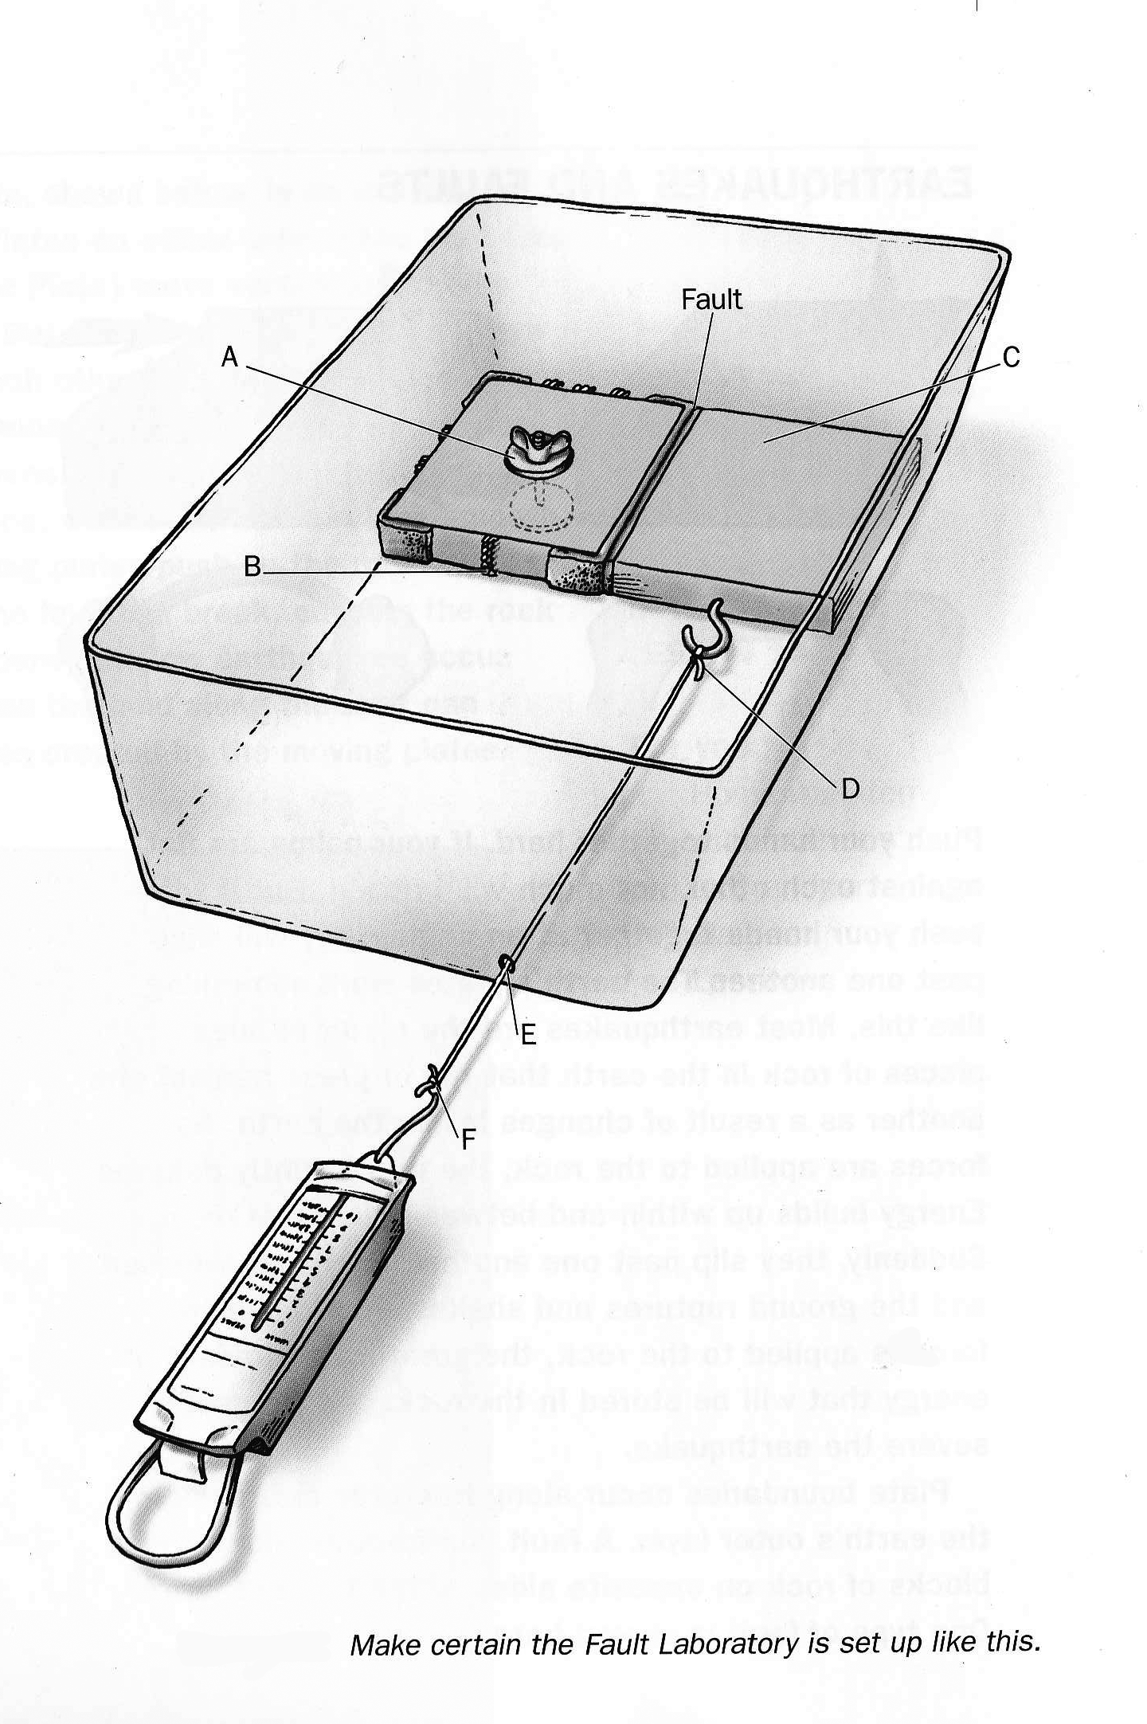
Procedure:
- Carefully place the blocks so that the Velcro surfaces face each other

- Notice how each side of the block on the left has a different number of strips of “hooked” Velcro. For each test, you will rotate the block so there is more hooked Velcro or frictional resistance between the two blocks.

- Experiment with the unfixed block. How does the block move when you pull it? Try putting masking tape across the boundary, or fault, where the two blocks meet. Pull on the block again. What happens to the tape that indicates stress is building along the fault? Reset the blocks. Place houses (plastic centimeter cubes) on the blocks along the fault. Pull on the block again.

- Remove the tape and houses. Collect and analyze data to find out how the amount of frictional resistance along a fault affects the way it ruptures. Pull on the spring scale. How much force do you have to apply to the block before the fault ruptures (before the block moves abruptly?) Try every combination of velcro and non-velcro sides.

- Create your own data table that includes whatever your team feels important as a variables to record. ex: a. Number of velcro strips
b. Amount of force necessary to move the block
c. Distance in mm that the block moves before releasing
(Geologists call this gradual slippage “creep”)

Four Part LMS Conclusion:

- Purpose/Hypothesis
- Background
- Important Observations (Was your hypothesis correct? Why or Why not? Give data to support your reasoning. How does this lab relate to real life plate boundaries and movements?)
- Errors/Similar labs

